* Copier le dossier oracle driver

L:\CACEIS-CARAR$\GR-IT\ADM\ISSUERS\General\OLIS Team\Secteur OLIS\10- Uptevia\01 - REFONTE OLIS\stream olis investisseur\dev\jboss module\oracle

dans C:\Public\SOFTWARE\wildfly-26.1.3.Final\modules\system\layers\base\com\oracle

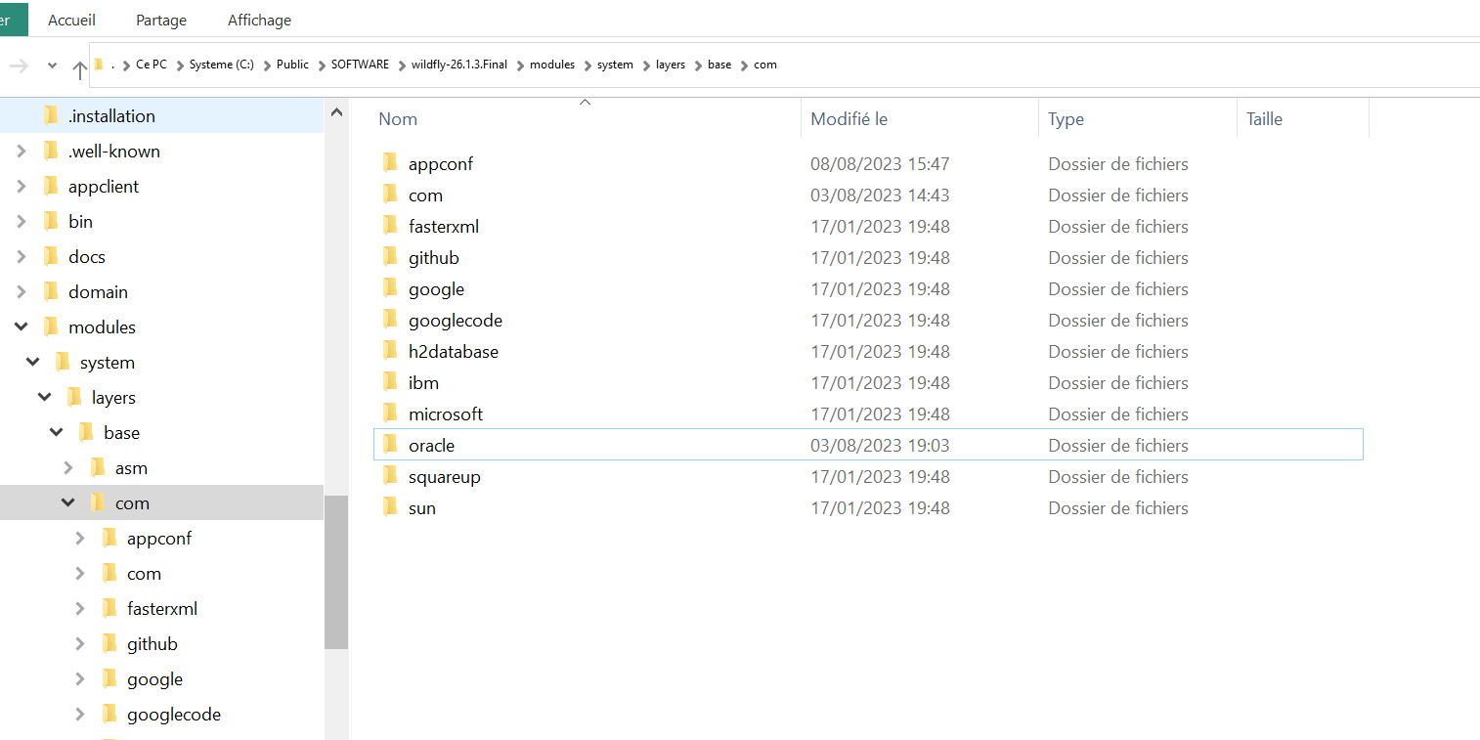

* Ajouter la config dans standalone.xml au niveau de domain:datasources

[BS] : chemin C:\Public\SOFTWARE\wildfly-26.1.3.Final\standalone\configuration\standalone.xml

<subsystem xmlns="urn:jboss:domain:datasources:7.0">

<datasources>

<datasource jndi-name="java:/jdbc/uptevia" pool-name="Oracle">

<connection-url>jdbc:oracle:thin:@orfrer11.prod.lux.ca-indosuez.com:1521:ORFRER11</connection-url>

<driver>oracle</driver>

<security>

<user-name>UPTEVIA</user-name>

<password>UPTEVIA123_#5</password>

</security>

<validation>

<valid-connection-checker class-name="org.jboss.jca.adapters.jdbc.extensions.oracle.OracleValidConnectionChecker"/>

<validate-on-match>true</validate-on-match>

<exception-sorter class-name="org.jboss.jca.adapters.jdbc.extensions.oracle.OracleExceptionSorter"/>

</validation>

</datasource>

<datasource jndi-name="java:jboss/datasources/ExampleDS" pool-name="ExampleDS" enabled="true" use-java-context="true" statistics-enabled="${wildfly.datasources.statistics-enabled:${wildfly.statistics-enabled:false}}">

<connection-url>jdbc:h2:mem:test;DB_CLOSE_DELAY=-1;DB_CLOSE_ON_EXIT=FALSE</connection-url>

<driver>h2</driver>

<security>

<user-name>sa</user-name>

<password>sa</password>

</security>

</datasource>

<drivers>

<driver name="oracle" module="com.oracle">

<driver-class>oracle.jdbc.driver.OracleDriver</driver-class>

</driver>

<driver name="h2" module="com.h2database.h2">

<xa-datasource-class>org.h2.jdbcx.JdbcDataSource</xa-datasource-class>

</driver>

</drivers>

</datasources>

</subsystem>

[BS] : Avant ajout

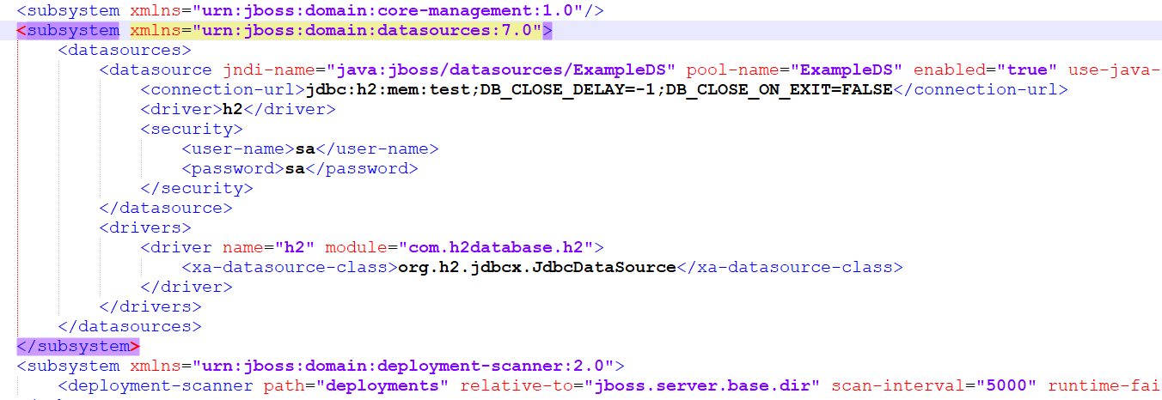

[BS] : Après ajout

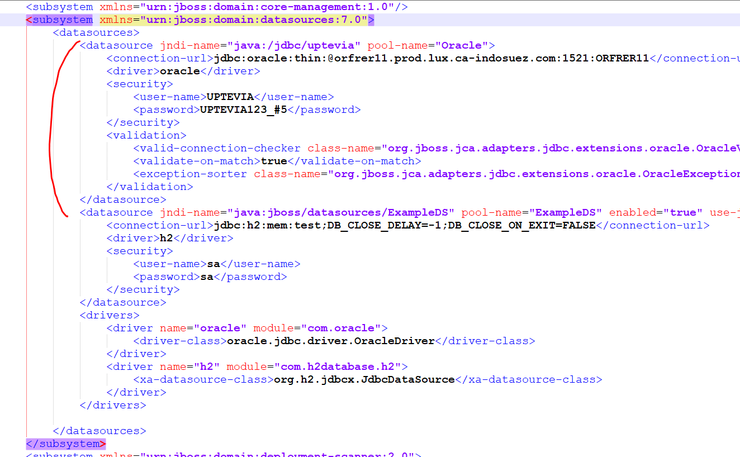

[BS] : Après ajout de la deuxième Data Source

<datasource jndi-name="java:/jdbc/oraoaec01" pool-name="Oraoaec01">

<connection-url>jdbc:oracle:thin:@cacdbsddc921.prod.lux.ca-indosuez.com:1521:ORFRER11</connection-url>

<driver>oracle</driver>

<security>

<user-name>ORAOAEC01</user-name>

<password>NVSGYF67</password>

</security>

<validation>

<valid-connection-checker class-name="org.jboss.jca.adapters.jdbc.extensions.oracle.OracleValidConnectionChecker"/>

<validate-on-match>true</validate-on-match>

<exception-sorter class-name="org.jboss.jca.adapters.jdbc.extensions.oracle.OracleExceptionSorter"/>

</validation>

</datasource>

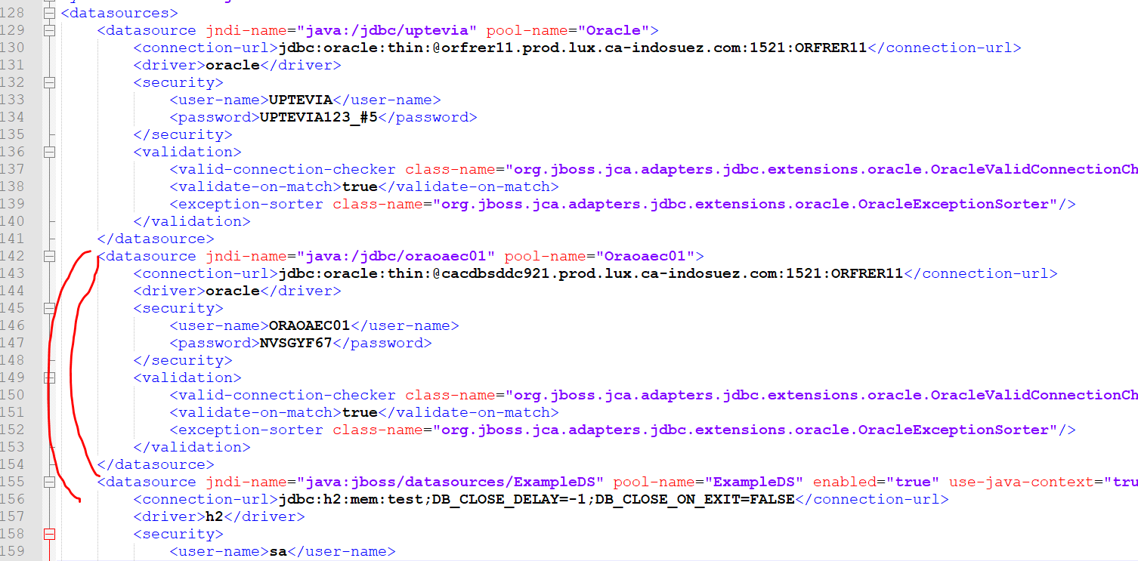

[BS] : Ajout de la 3ème Data Source

<datasource jndi-name="java:/jdbc/olis" pool-name="Olis">

<connection-url>jdbc:oracle:thin:@orfrer11.prod.lux.ca-indosuez.com:1521:ORFRER11</connection-url>

<driver>oracle</driver>

<security>

<user-name>olis</user-name>

<password>Aqwzsx01</password>

</security>

<validation>

<valid-connection-checker class-name="org.jboss.jca.adapters.jdbc.extensions.oracle.OracleValidConnectionChecker"/>

<validate-on-match>true</validate-on-match>

<exception-sorter class-name="org.jboss.jca.adapters.jdbc.extensions.oracle.OracleExceptionSorter"/>

</validation>

</datasource>

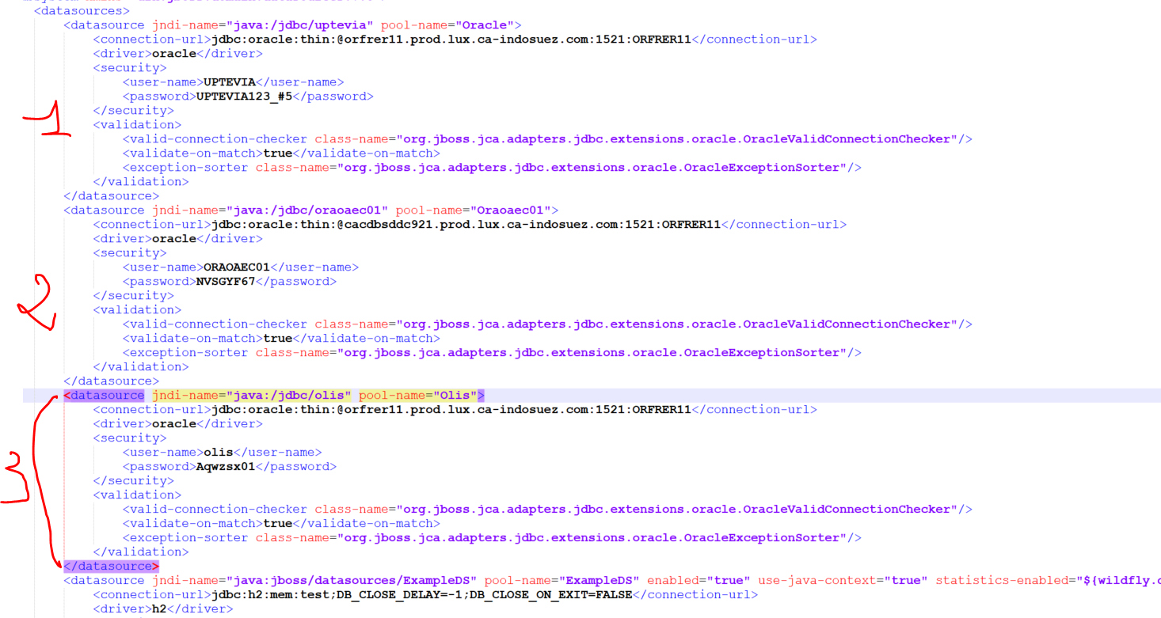

Appliquer le changement du log pour la class « **slf4j »**

Dans le standalone.Xml qui se trouve dans : C:\Public\SOFTWARE\wildfly-26.1.3.Final\standalone\configuration.

-supprimer le bloc s’il y’en a :

<subsystem xmlns="urn:jboss:domain:logging:8.0">  
..  
..  
</subsystem>sssssssss

-Puis redémarrer le serveur

[AN] : Ajout de la 4ème Data Source (REGIS)

<datasource jndi-name="java:/jdbc/regis" pool-name="Regis">

<connection-url>jdbc:oracle:thin:@orfrer11.prod.lux.ca-indosuez.com:1521:ORFRER11</connection-url>

<driver>oracle</driver>

<security>

<user-name>regis</user-name>

<password>regis</password>

</security>

<validation>

<valid-connection-checker class-name="org.jboss.jca.adapters.jdbc.extensions.oracle.OracleValidConnectionChecker"/>

<validate-on-match>true</validate-on-match>

<exception-sorter class-name="org.jboss.jca.adapters.jdbc.extensions.oracle.OracleExceptionSorter"/>

</validation>

</datasource>

-ajouter la nouvelle datasource après celle de « olis »

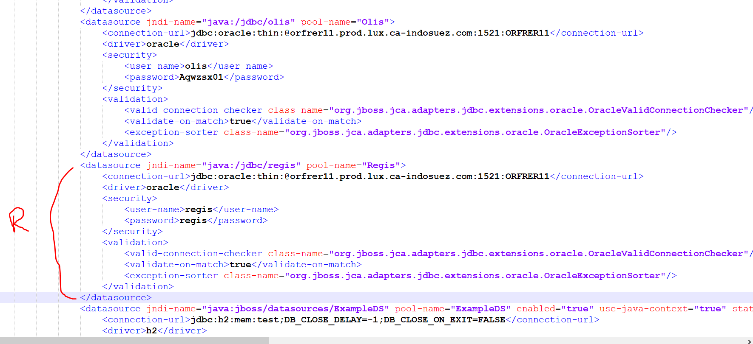

-Redémarrer wildfly